PAPER template USE FORMAT called “PAPER TITLE_NMG”
First A. Author, Second B. Author, and Third C. Author

Keywords
NGM, Abstract, Instructions, Formatting, Template, Typesetting

Abstract
This template provides instructions for preparing a paper to the 19th Nordic Geotechnical Meeting. Please use the formats included in this document and note that the heading för keywords, abstract, acknowledgement and references is not numbered. There is also a separate heading for the authors.
The template can be directly used to write the paper. All papers must be written and spell-checked in English (UK or US English is ok, as long as the writing is consistent). Papers should be edited for clarity and grammar before being submitted.
Use of paragraphs is encouraged to make the text more accessible and easier to read.

example introduction
This is the main text format named Main text_NGM. The text between the abstract and acknowledgement are divided into chapters where the heading is numbered. The heading is in the format Heading 1 numbered_NGM.
Second heading
If you would like to use a second heading then use the format Heading 2_NGM.

example method
This is the main text format named Main text_NGM. If you would like to include a figure in your paper then place the figure text below the figure and use the text format Figure_NGM. All figures should be numbered consecutively and captioned.
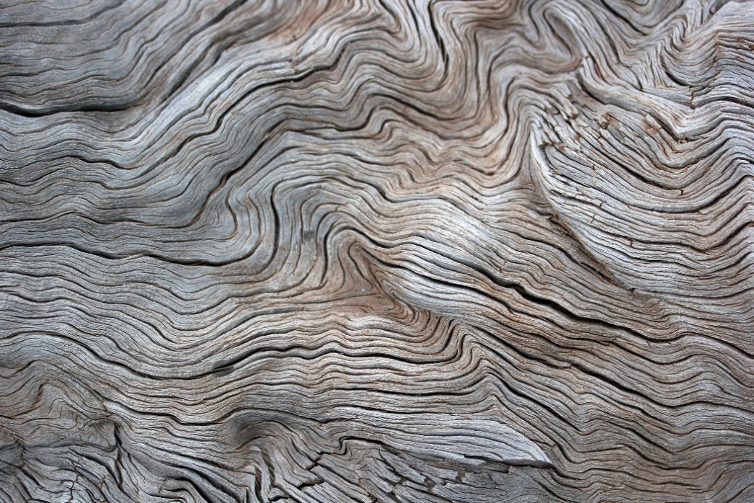
Figure 1 The format of this text is called Figure_NGM.
This is the main text format named Main text_NGM.

example analysis
This might be the place to insert a table. The title of the table describing its’ content is placed above the table in the format Table_NGM. The layout of the table is for you to choose. Tables should be numbered consecutively and separately from the figures.
Table 1. Example.

example Conclusions
This is where you sum up your interesting findings.

Acknowledgement
Anyone you would like to thank, someone who has funded your work? This optional heading should be inserted just before the References heading.

REFERENCES
[1] A. B. Andersson: Preparing for the geotechnical challanges. PhD thesis, Chalmers University of Technology, 2020.
[2] C. Svensson et al.: Geotechnical Engineering in the future. Journal of Geotechnical Engineering, vol. 1, 2023.

Institution of first author
Institution of second author
Institution of third author

